**T.A. Solutions**



**TA Solutions Final Report**

Author: Brian Blondet

Creation Date: 05/12/2020

Last Revised: 05/12/2020

T.A. Solutions created an open source platform to provide administrators of tutoring programs a means to easily monitor their program by digitally logging student sessions and tutor hours and offer tools such as automated flagging, and data analytics. However, due to time constraints and the Coronavirus Epidemic we were not able to test our platform with Kean University’s tutoring program. The purpose of this report is to summarize the work that has been completed and provide guidelines for future work.

The current version of the product was developed for web and android application because our original goal was to test data analytics with the Kean tutoring program. We felt that by offering our users multiple platforms would result in more accurate digital logs. Apple IOS was not created due to our time constraint.

Both applications use MySQL to store user data and provide a means of access controls between user roles. Currently, there are four types of users on the platform defined as the following:

* Administrator: Technical expert with experience in MySQL database management
* Supervisor: An administrator of tutoring department
* Tutor: Student allowed to tutor for specific departments
* Student: Base user that seeks tutoring

Below is a more detailed diagram regarding user roles, features, and access controls. For more information regarding this topic please see Software Requirement Specifications document

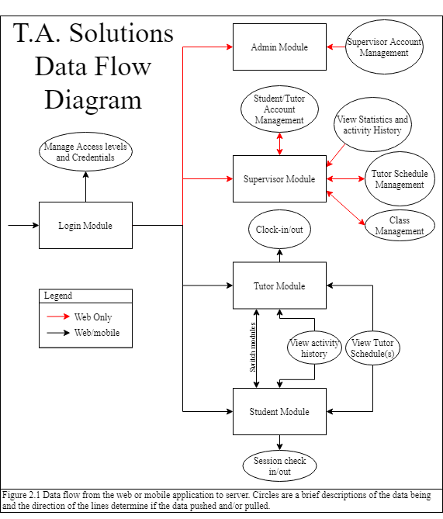

Furthermore, both applications use PHP/MySQLi scripting to insert and select data as needed from their respective platforms. Therefore, the following schema of tables is needed to run the applications properly.

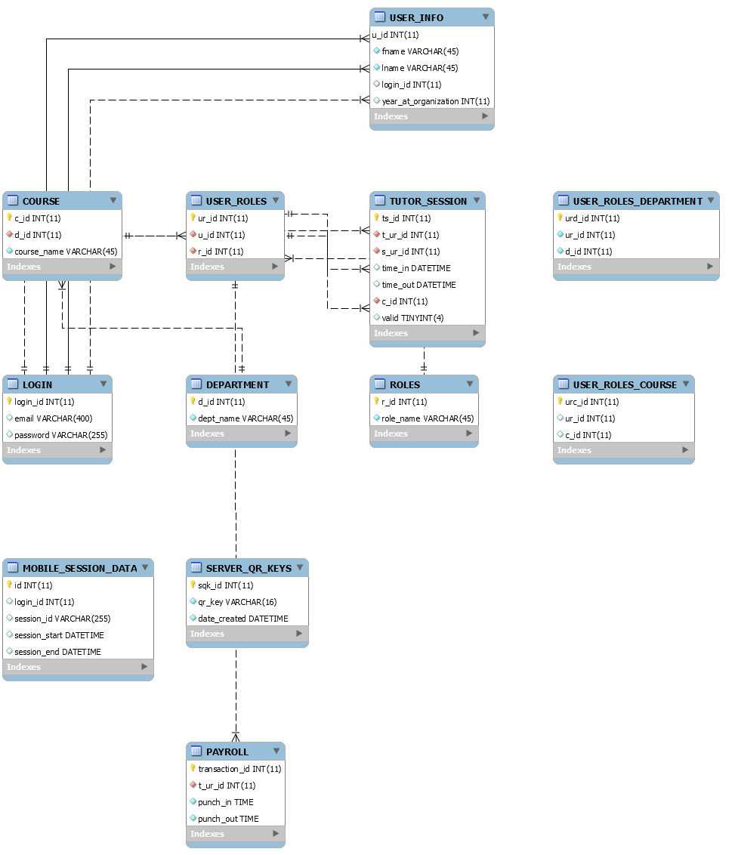

The data analytics we planned on introducing to supervisors relied on comparing traffic the from previous semester(s) to estimate future traffic. However, testing this feature was difficult since all in person tutoring and was interrupted by Coronavirus. We recommend that any future work with TA Solutions consist of live testing and debugging both platforms as well as implement missing features from the Software Requirement Specifications document.